COB Editor User Manual
by Peter Wong and Jie Bao

Installation

Prerequisites
The COB Editor relies on the following pieces of software to run properly:
- Java Runtime Enviroment (JRE) 1.5 and above
- PostgresSQL 8.0
  - Standard PostgresSQL installation
  - JDBC PostgresSQL drivers

[Fill in later]

Running the COB Editor

[Fill in later]

Connecting to an Existing COB Ontology Server

Prerequisite Knowledge
- Ontology Server Address (ex. localhost, 127.142.123.12, etc.)
- Type of Server (PostgresSQL, MySQL, Oracle)
- Username and Password for access

Step 1 Choosing an Ontology

With the mouse, select from the menu bar Setting → Choose Ontology

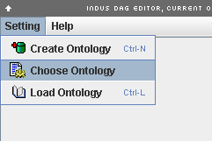

Step 2 Specifying Server Information

To access a particular ontology, the necessary information to connect to the database hosting the ontology, and username, password to access that database must be specified. The Ontology Server Setting dialogue box will popup after completing Step 1. Click the “New” button to start specifying a new ontology to connect to. Continue by filling each field.

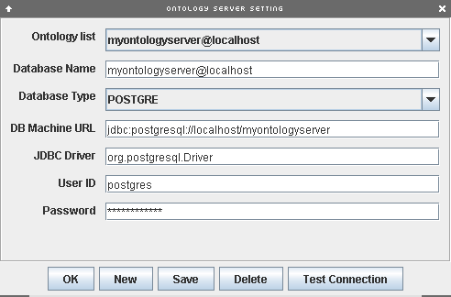
Step 2 Specifying Server Information (continued…)

You can check the validity of the supplied information by clicking the “Test Connection”. If the information supplied is correct, a dialogue box similar to the following will result.

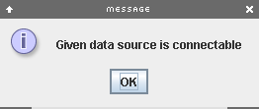

Click the “Save” button to save the server information for further use and then click the “OK” button.

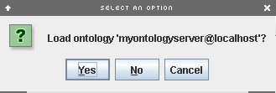

You will presented with a final dialogue box to reconfirm the ontology being loaded. Click the “Yes” button to finish the process.

Creating a new COB Ontology Server

Prerequisite Knowledge
- Database Address (ex. localhost, 127.142.123.12, etc.)
- Type of Database (PostgresSQL, MySQL, Oracle)
- Username and Password for Database access

Step 1 Choosing an Ontology

With the mouse, select from the menu bar Setting → Create Ontology

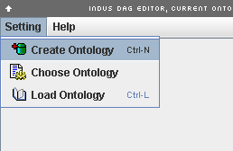

Step 2 Clicking next…

Click the “Next” Button to continue the process.

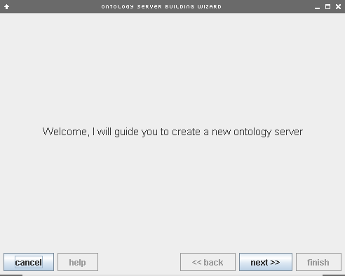

Step 3 Specifying Server Information

To create a new ontology, the necessary information about the database hosting the ontology, and username, password to access that database must be specified.

Host – The address that the database resides at
Default Table – The default table’s name
User - The username allowed to create users and tables on the database
Password – The password for that username.

Click the “Next” button to continue the process.

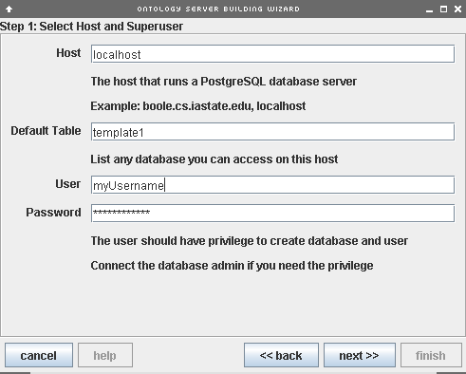

Step 4 Specifying Server Information

This page of the setup, the Ontology Server Name and the Public Access Settings are specified.

